Will Morland Mouse Click Game Written Report 24797112
Contents
Will Morland Mouse Click Game Written Report 24797112 1
First Class 1
Second Class and Kill Function 2
Enemy Array -> ArrayList 3
Enemy Animation 4
Obstacle Class with Inheritance 5
High Score Feature 6
Interface 8
Collisions 10

First Class
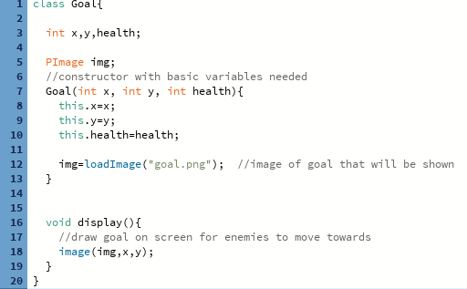
First class was the goal in which the enemies will target (Goal, lines 1-20)

Second Class and Kill Function
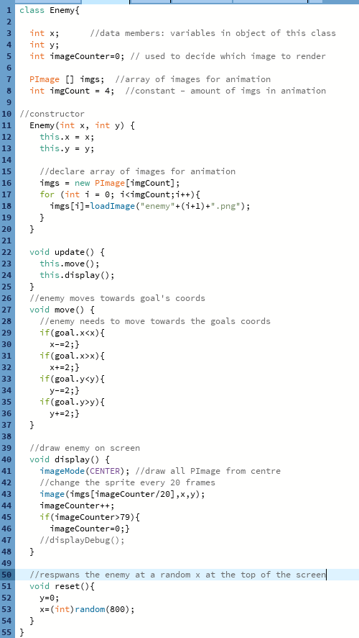
Enemy class lines 1-49. This contains all the data used to make the enemy move towards the goal and animate.
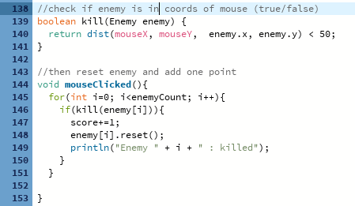
Kill function within main mouseGame class lines 138-153, if an enemy is killed then the score is increased by 1

Enemy Array -> ArrayList
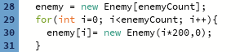
mouseGame lines 1-2
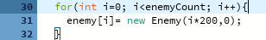
Original enemy declaration in mouseGame using the constructor in the Enemy class.
As I updated my project, I needed my array to vary in length with enemies becoming null once killed and increasing numbers of enemies. As an array has a static length number I changed it to and ArrayList.
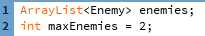
Max enemies will be used later to stop too many enemies being on the screen at once
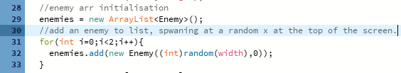
ArrayList initialisation where only 2 are spawned at the start of the game
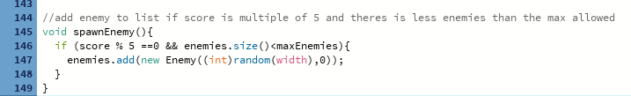
This will increase the difficulty of the game over time by dynamically creating more enemy objects. This is called within draw() of mouseGame to keep checking the score and enemy count

Enemy Animation
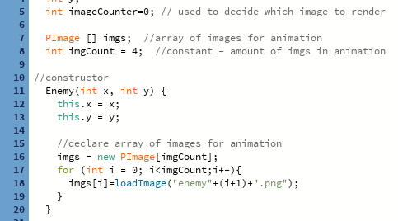
Enemy animation array declaration
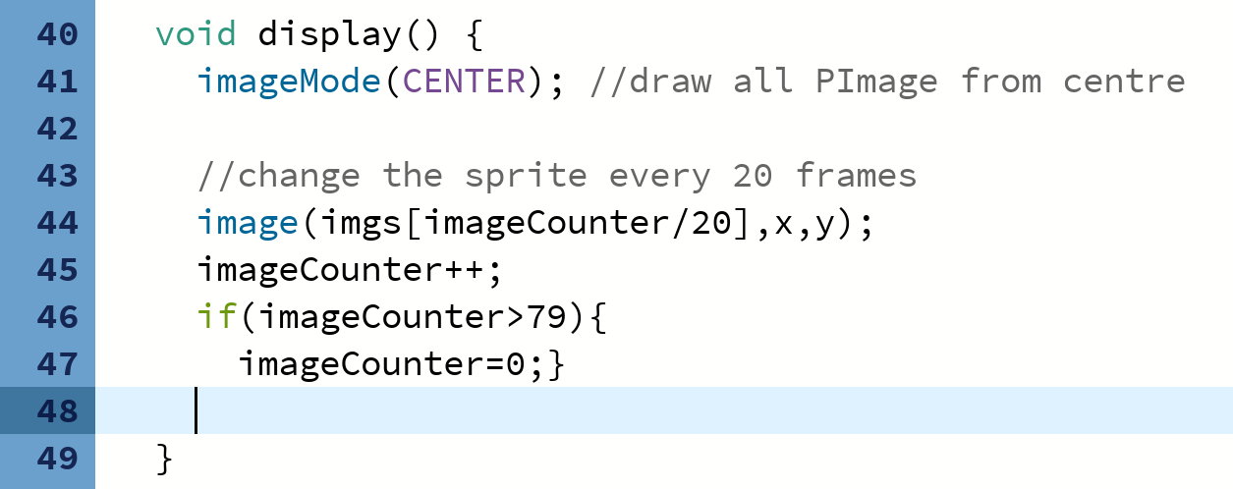
Display() is called once a frame in draw(), where imageCounter is increasing by 1. Every time imageCounter reaches a multiple of 20 the current frame of a set of sprites increases by one. This can be easily adapted in the future if more frames are wanted by increasing the limit above 79 or choosing a number lower than 20 for a smoother animation.

Obstacle Class with Inheritance
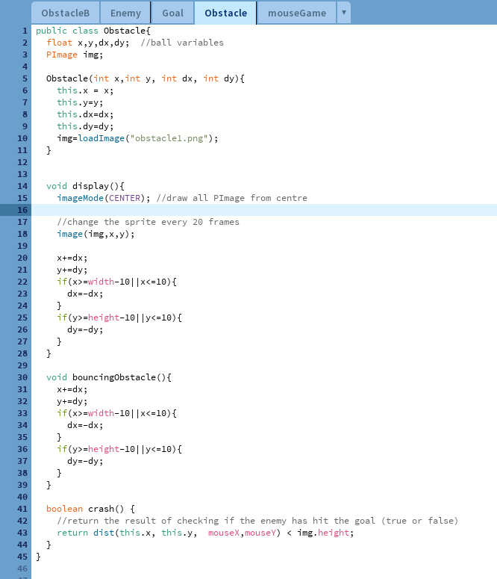
Main obstacle class
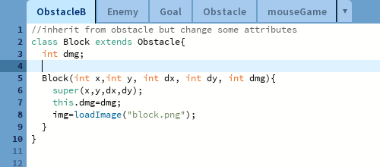
This is a second obstacle class that inherits from Obstacle. It contains all the main variables from obstacle plus an extra damage variable, where it will instantly kill the player.
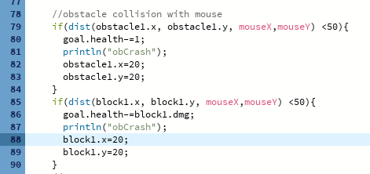
This part of mouseGame detects if either the obstacle or its child is in range of the mouse to deal damage and the block does extra damage.

High Score Feature
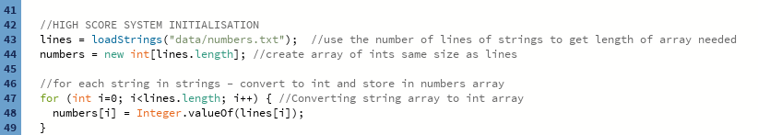
Initialisation of high scores (mouseGame, lines 42-49
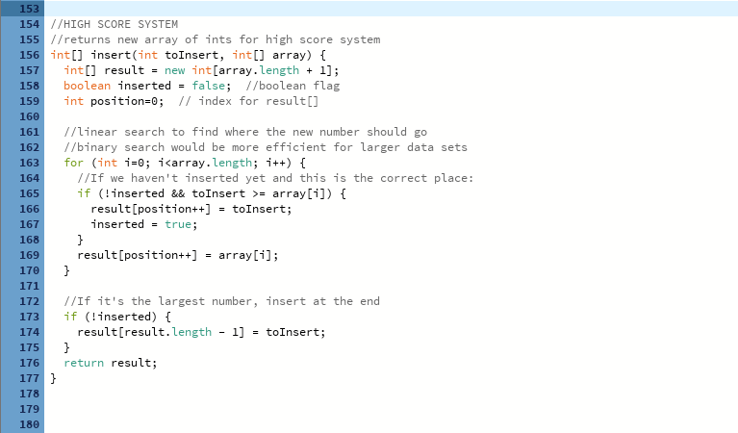
High score system in mouseGame class, lines 154-177. Returns the new array of high scores to end screen
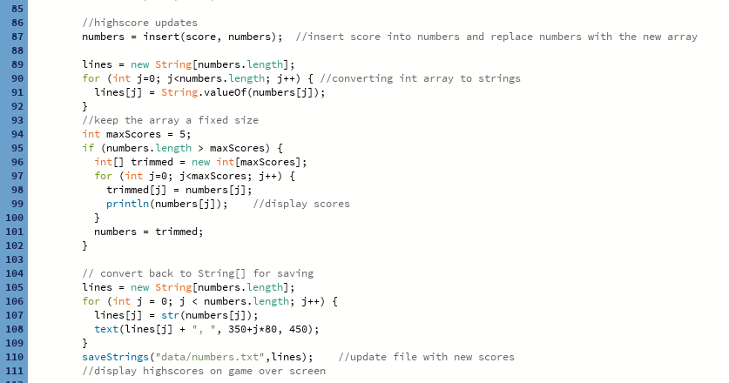
High score system with game over section when health is 0 mouseGame class lines 86-111).

Interface
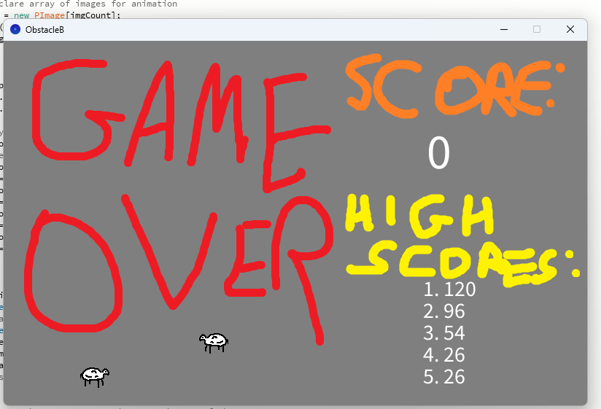
Death screen at the end of the game displaying the score and previous highscores.
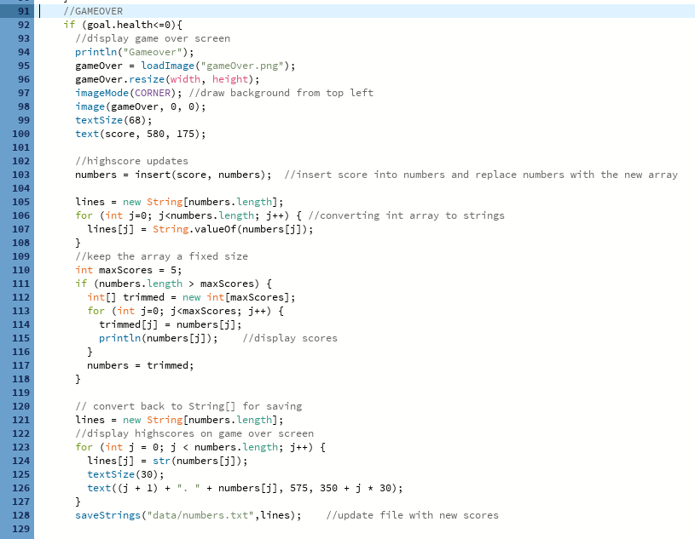
Code for displaying the high score list and score info once the goal health has decreased below 0. (mouseGame, lines 91-128)

Collisions
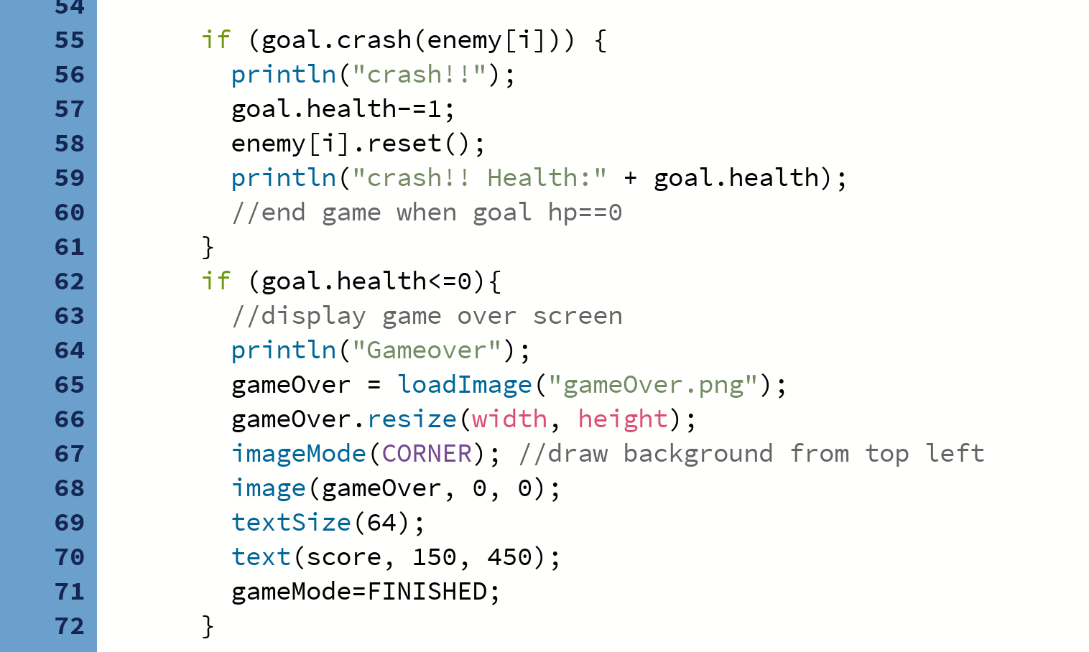

When an enemy reaches the goal that the player is defending, the goal’s health is decreased by one and the enemy is reset to prevent multiple collisions in one. A death animation is then called for that enemy. Once the goal’s health is equal to 0, a game over screen is displayed with the score and high score displayed.

